Lab#04

**Objective**: To learn report generation in OLTP systems.

Generate an OLTP system report which displays the following results:

1. **Total sales in a month** (Use only order table).

**STORED PROCEDURE:**

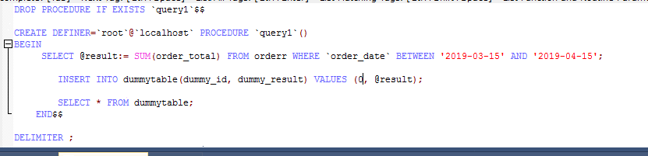

**RESULT:**

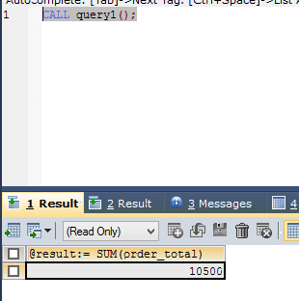

1. **Profit/loss in a month** (Use product (to account for purchasing costs), expenditure as well as order tables).

**STORED PROCEDURE:**

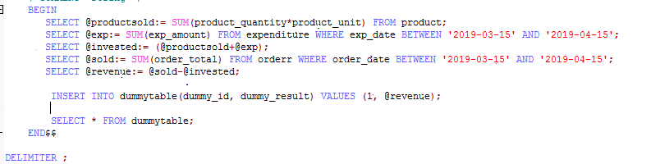

**RESULT:**

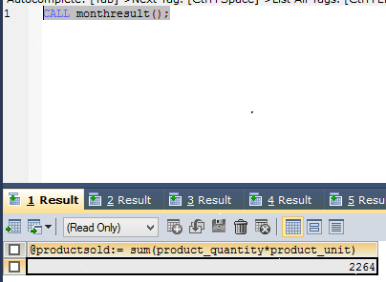

1. **Highest selling product of the month** (By highest sold quantity)

**STORED PROCEDURE:**



**RESULT:**



1. **Lowest selling product of the month** (By lowest sold quantity)

**STORED PROCEDURE:**

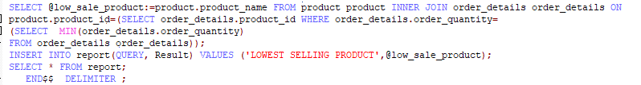

**RESULT:**

